3D Character & modeling scene in blender

Visualization and CAD (in English) 2019 Project

Brno University of Technology

Marios Pafitis (xpafit00)

Contents

**Chapter 1** - Introduction: 2

**Chapter 2** - Goals: 2

**Chapter 3** - Technologies & Tools Used: 2

**Chapter 4** - Motivation: 2

**Chapter 5** - Project Workflow Description: 2

5.1 Drafts: 2

5.2 Hero: 3

5.3 Gun: 4

5.4 Enemy: 4

5.5 Bush: 5

5.6 Trees: 6

5.7 Stones: 6

5.8 Scene: 7

**Chapter 6** - Results: 7

**Chapter 7** - Conclusion: 9

**Chapter 8** - References: 9

List of Figures

Figure 1 - Enemy Draft 3

Figure 2 - Inspiration Image for Hero and Enemy 3

Figure 3 - Hero Draft 3

Figure 4 - Hero Angle 3

Figure 5 - Hero Front 3

Figure 6 - Hero Side 3

Figure 7 - Hero Armature 4

Figure 8 - Holding Gun Front 4

Figure 9 - Holding Gun Angle 1 4

Figure 10 - Holding Gun Angle 2 4

Figure 11 - Gun 4

Figure 12 - Enemy Armature 5

Figure 13 - Enemy Side 5

Figure 14 - Enemy Front 5

Figure 15 - Enemy Angle 5

Figure 16 – Bush Models 5

Figure 17 – Tree Models 6

Figure 18 - Tree Models 6

Figure 19 - Scene Front View 7

Figure 20 - Scene Close Up 7

Figure 23 - Enemy Close Up 8

Figure 22 - Hero Close Up 8

Figure 24 - Side Scene View 8

Figure 25 - Top-down Scene View 8

# **Chapter 1** - Introduction:

This is a school project for the lesson Visualization and CAD (in English). The purpose of my project is to create 3D models for my game. I will present the models in a scene that I have created just for the purposes of the project. This is my first touch with a 3D modeling software so I made some research about principles of 3D modeling in order to create my models. Before I started the creation of my models I had to experiment with techniques and simpler models in order to get comfortable with the use of a 3D modeling software.

# **Chapter 2** - Goals:

For my project I created the graphics for a 3D game I would like to implement in the future. The project contains the graphics for:

* Hero (Spartan skeleton character)
* Enemy
* Gun
* 4 models for trees
* 4 models for stones
* 3 models for bushes

I will present the models above in a scene in order to see how they will look in the real game.

# **Chapter 3** - Technologies & Tools Used:

* Blender 2.8 (3D Modeling)
* Maxon Cinema 4D (Presentation)

# **Chapter 4** - Motivation:

I wanted to create something based on low poly. Low poly is a 3D modeling technique in which you can see the rough edges of the shapes. So, the graphics will not have smooth surfaces. I used this technique because I was confident that I could create something that looks nice. After some research I understood that creating something realistic is much hard to make it look realistic than just creating something more abstract. I would have to think more about dimensions and anatomy if the model that I wanted to create was a character. Also, I like 3D games with that style of graphics and I wanted to try something similar too.

# **Chapter 5** - Project Workflow Description:

## 5.1 Drafts:

For the Hero and the Enemy, I found a picture online with characters that I would like to have in my game. I made some drafts in paper based on the picture I found and imported them in blender. In that way I could easily have sense of what I am doing in the 3D model. The end result turned out to be a little bit different from the drafts because in the creation state I thought it would be better to do it in a certain way. I liked the fact that the enemy had glowing eyes so I wanted to do the same for my 3D model too. I should use glowing material in order to make them glow. Moreover, I saw that the 3D models of characters should be presented in cross position that helps us later for rigging and animating.

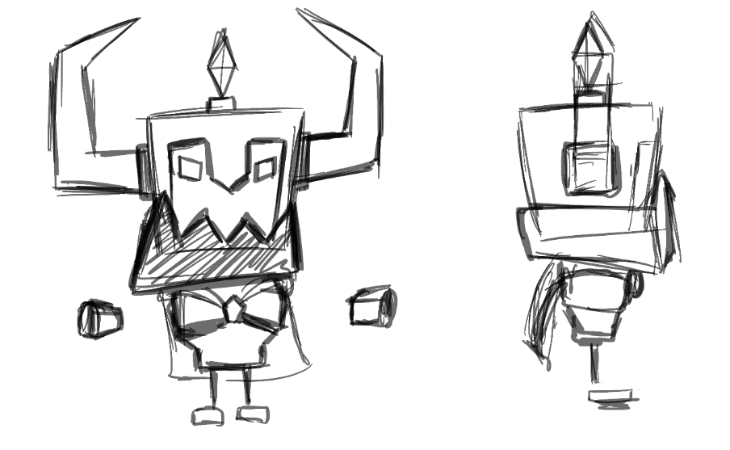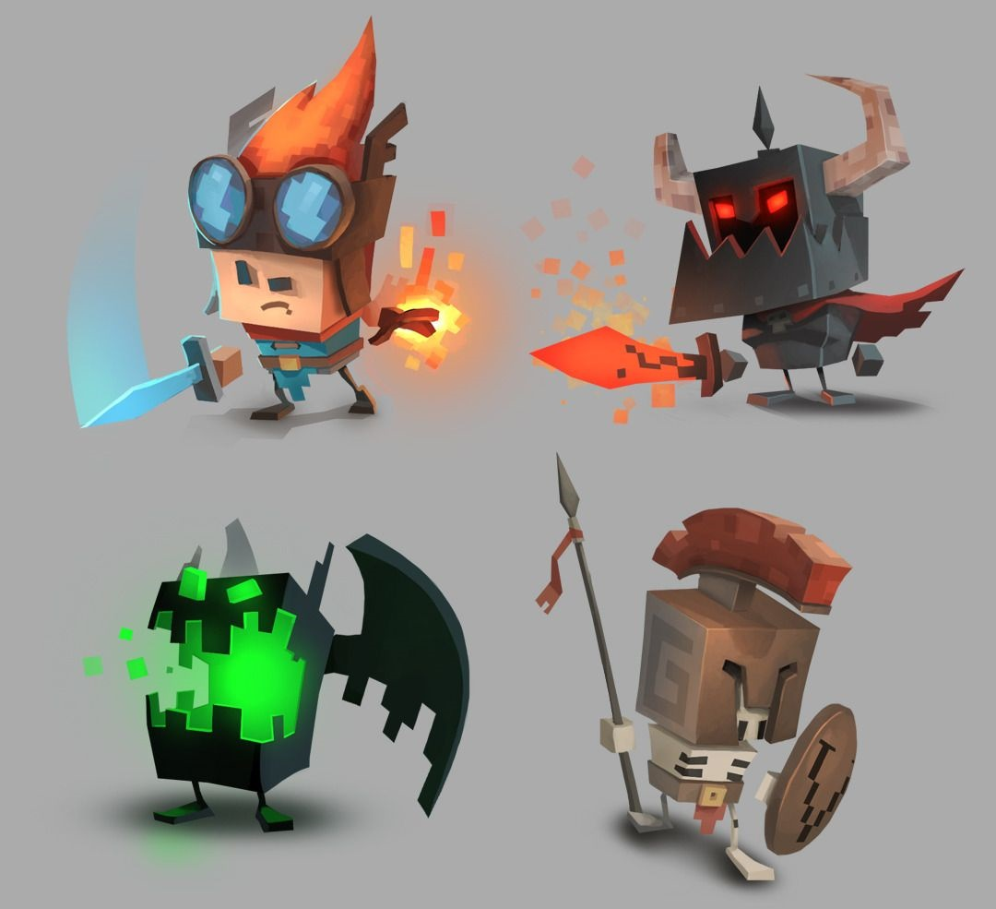

Figure 1 - Enemy Draft

Figure 2 - Inspiration Image for Hero and Enemy

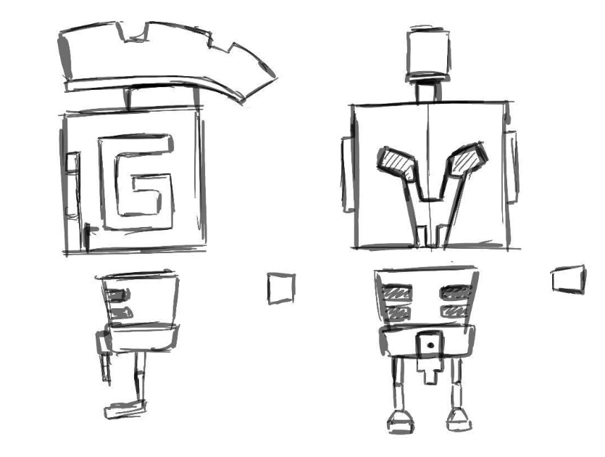

Figure 3 - Hero Draft

## 5.2 Hero:

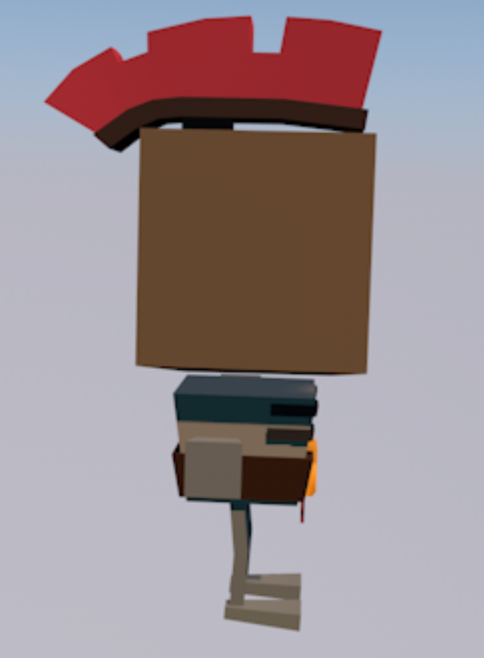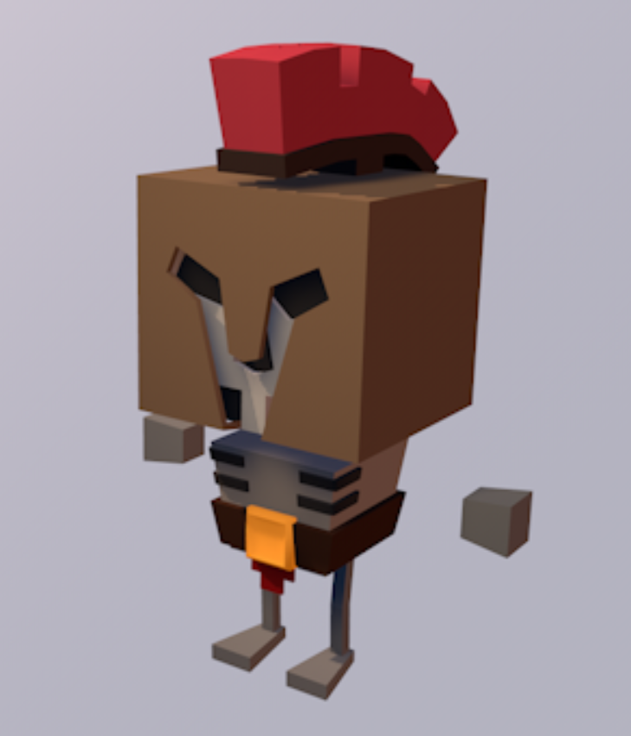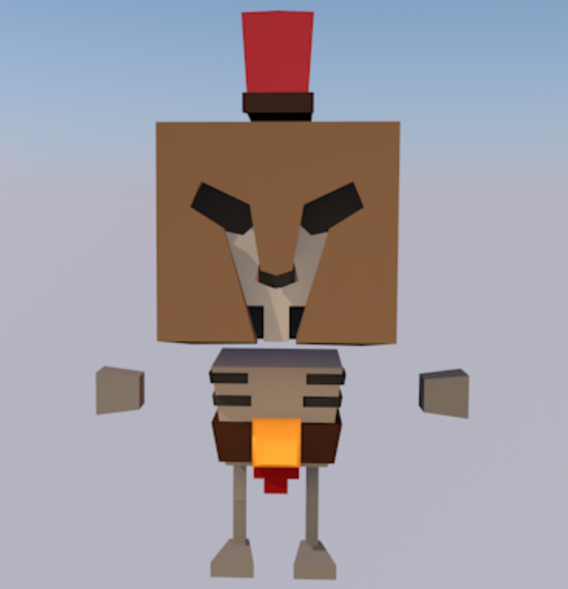 My hero is a Spartan skeleton character. Basically, is a skeleton with a helmet and a belt. The uniqueness of the hero is the metallic gold material in his belt. For the hero I made the rigging too. In the future I would like to animate it for the game. The whole 3D model is using the Mirror Modifier. To make the face I used a technique in which you start shaping by using a plane. You shape the front of the face at the beginning by extruding sides vertically. When you finished shaping the front of the face you turn the model 90 degrees to the side. Then you start extruding the sides of the face. I used as base the two drafts that I made by hand to create the shape that I wanted. For the arms I have used two cubes and for the feet too. The legs of the hero consist of two parts in order to be able to fold them in half in the animations. The rigging of the character has only the necessary bones in my case. For example, I don’t have fingers so it is not important to have any bones there.

Figure 4 - Hero Front

Figure 5 - Hero Side

Figure 6 - Hero Angle

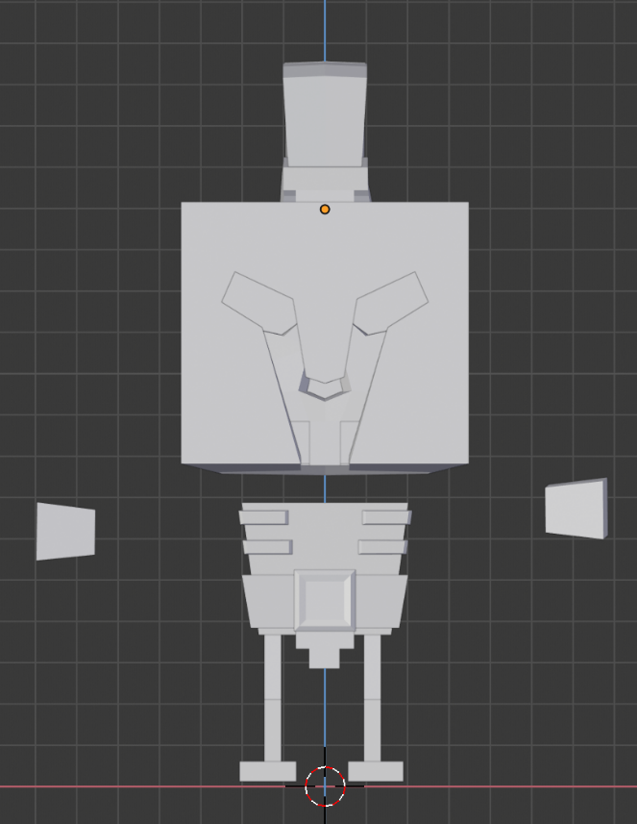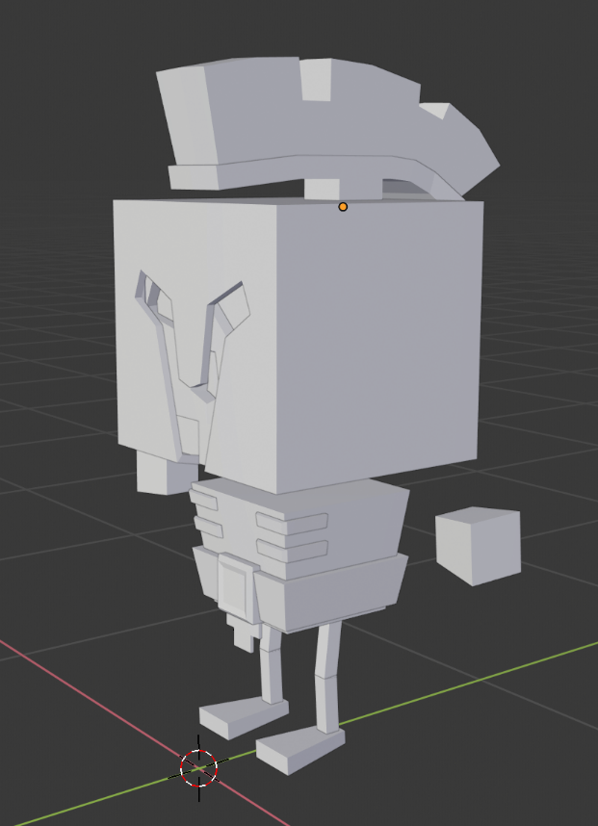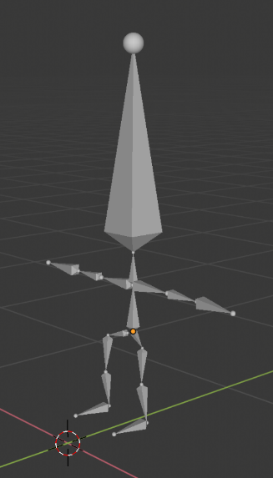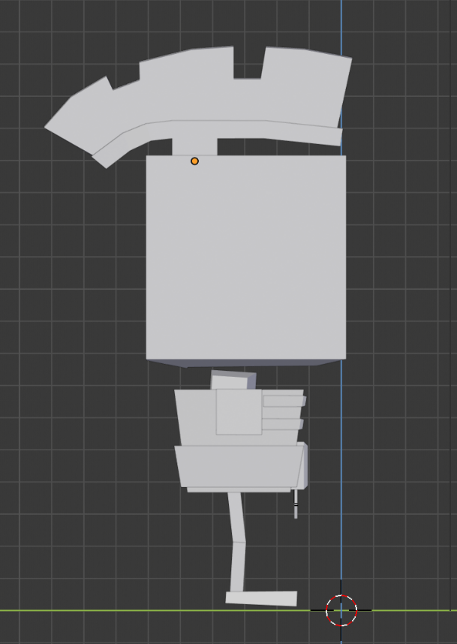

Figure 7 - Hero Armature

## 5.3 Gun:

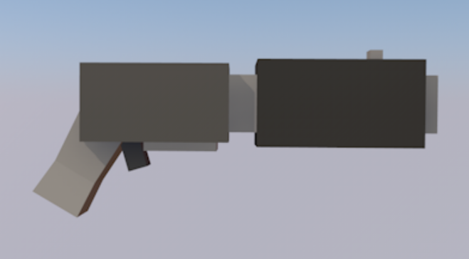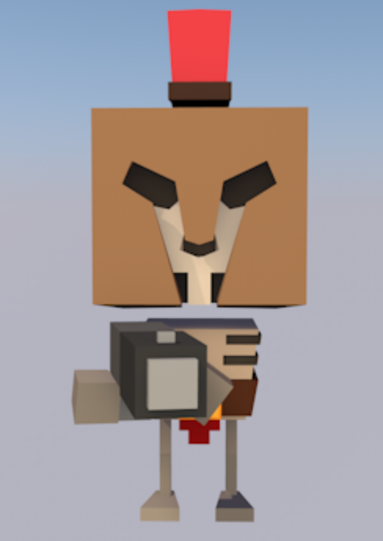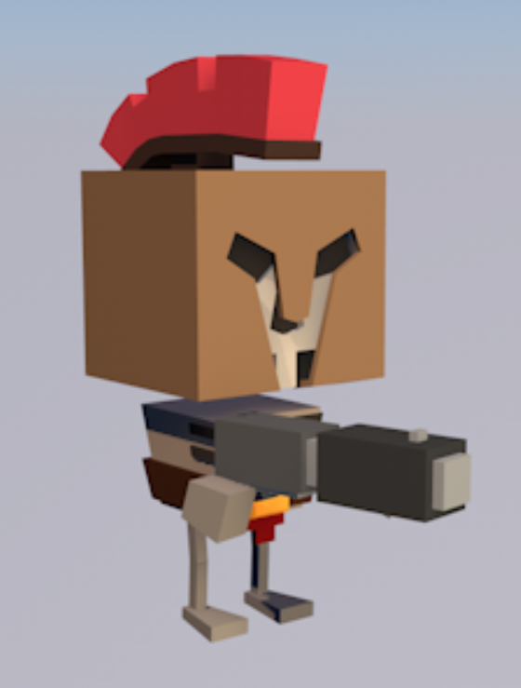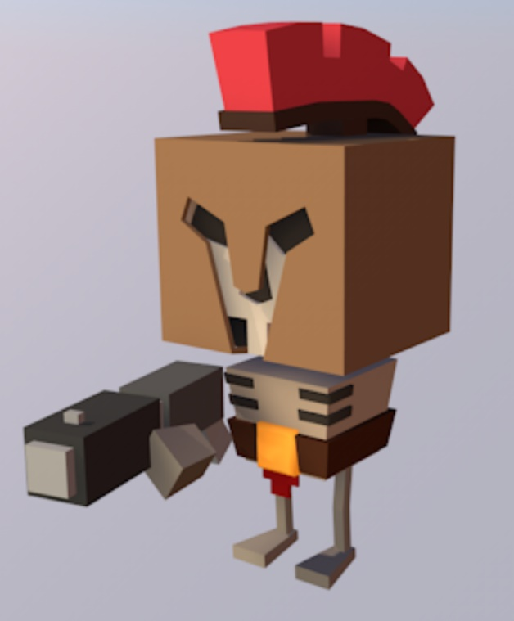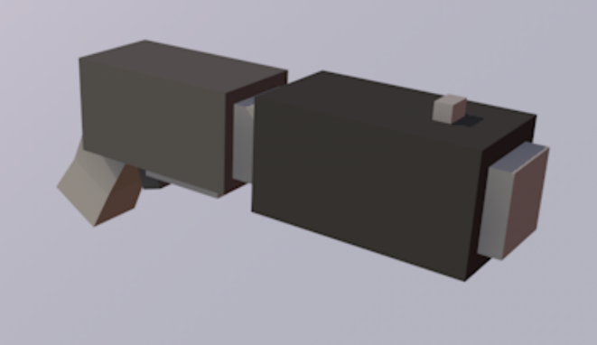The hero has to hold a weapon. I know, as a Spartan he should hold a spear but because we live in 2019 a made a gun for him. The gun had multiple parts that they are consisted of simple shapes. We can see the position from different angles of the hero while he is holding the gun.

Figure 8 - Holding Gun Front

Figure 9 - Holding Gun Angle 1

Figure 10 - Holding Gun Angle 2

Figure 11 - Gun

## 5.4 Enemy:

My enemy is an evil character with horns. The material for his eyes and the gem in his head is glowing in order to increase the evilness of the character. I made the rigging for the enemy too because I will animate it in the future. The enemies don’t have any weapons because the will move toward to the hero and bite him. To create the phase of the Enemy I used a plane as I did in the case of the Hero too. In the Enemy I didn’t use the Mirror Modifier for the face, just for the rest of the body. I used the extrude tool to make the horns. For the body I used a cube and I subdivided it to shrink specific areas. For the arms and the feet, I used again some cubes. In order to increase the evilness of the Enemy I have created a small skull head and placed it in his chest. The legs of the Enemy are a single cylinder and not two parts like the Hero. This is because I would like to move the Enemies with robotic steps and not like natural walking movement.

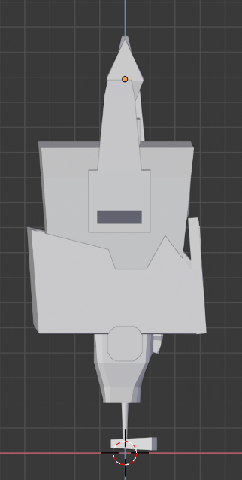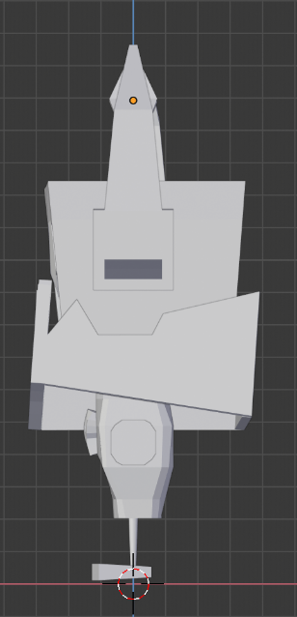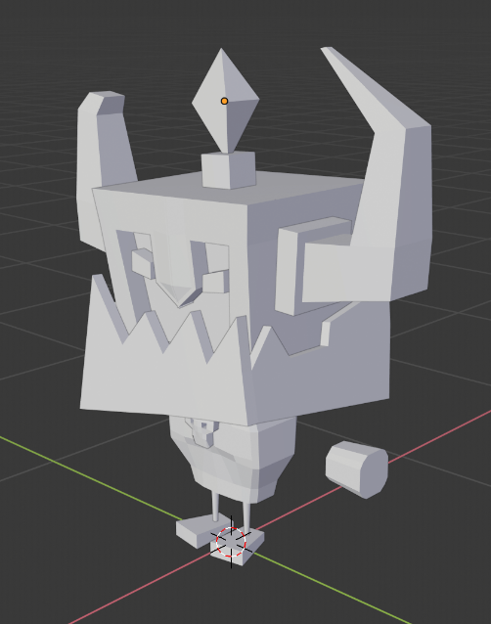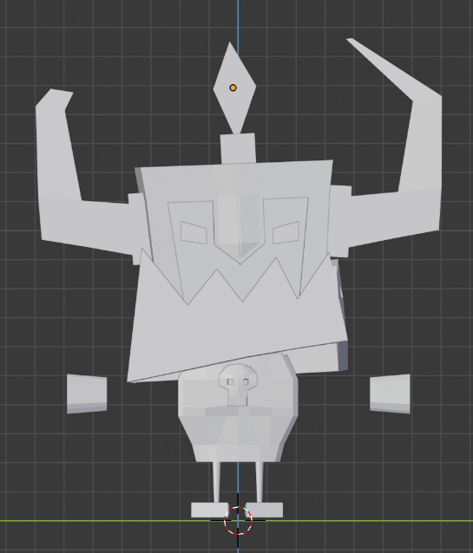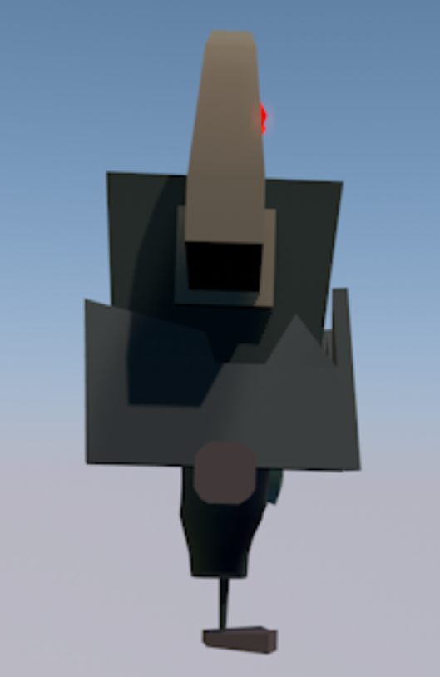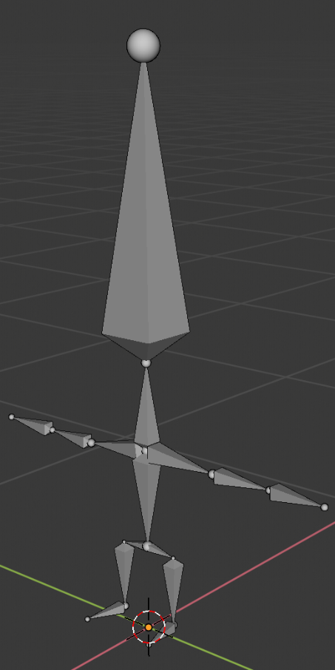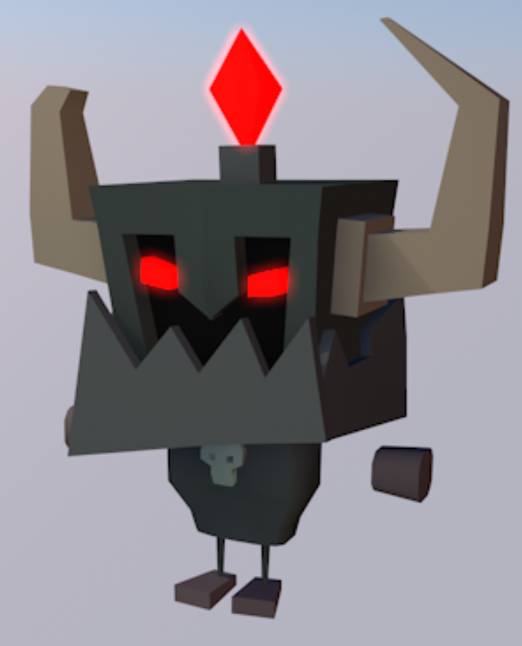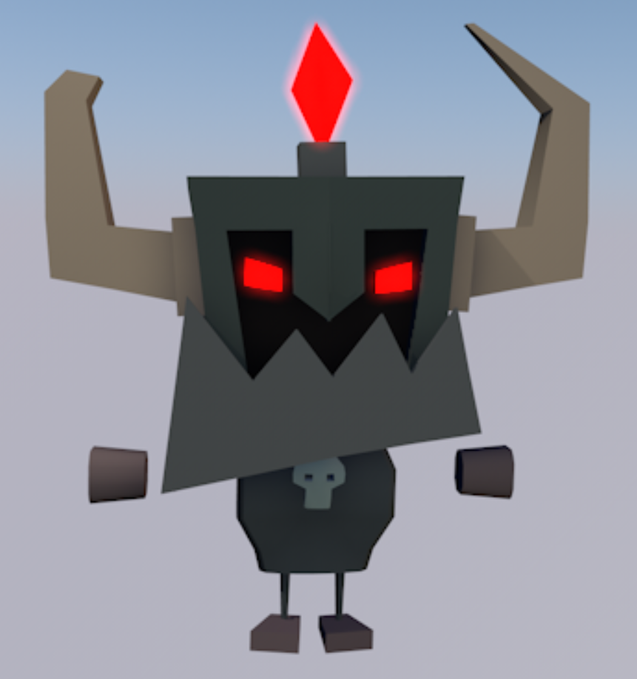

Figure 12 - Enemy Armature

Figure 13 - Enemy Side

Figure 14 - Enemy Front

Figure 15 - Enemy Angle

## 5.5 Bush:

I have created three different models of bushes. There are just simple ICO spheres with different sizes placed next to each other. The bushes will not have any functionality in the game, they will be used just for decoration purposes. I can easily resize them and change their rotation in order to look like new models in the scene. At the beginning, I was using UV spheres for the bushes. Later, I found out that the ICO sphere offer a more natural look for bushes. The UV spheres in the other hand they look too symmetric and there were not appropriate for natural shapes likes the leaves of a bush.

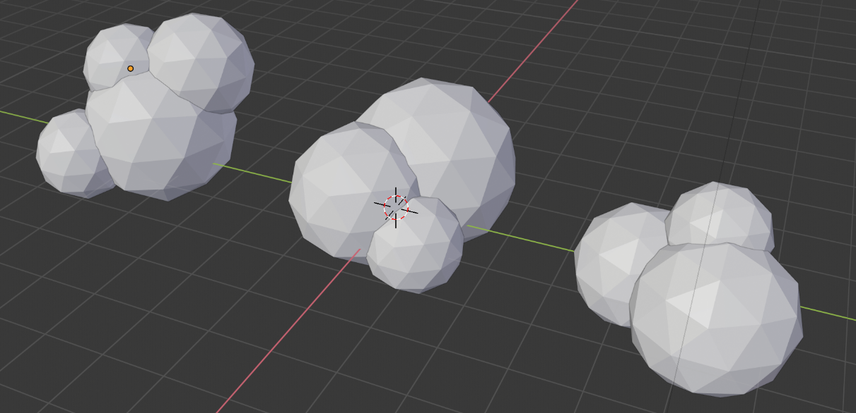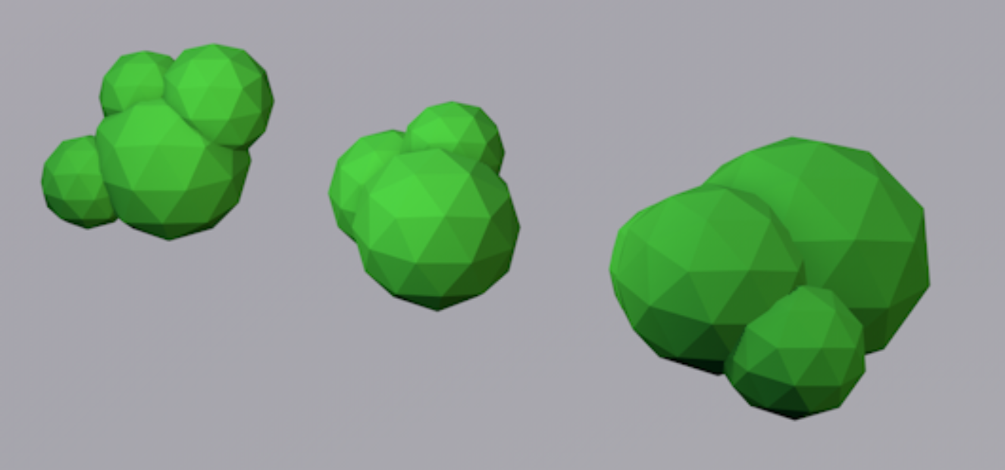

Figure 16 – Bush Models

## 5.6 Trees:

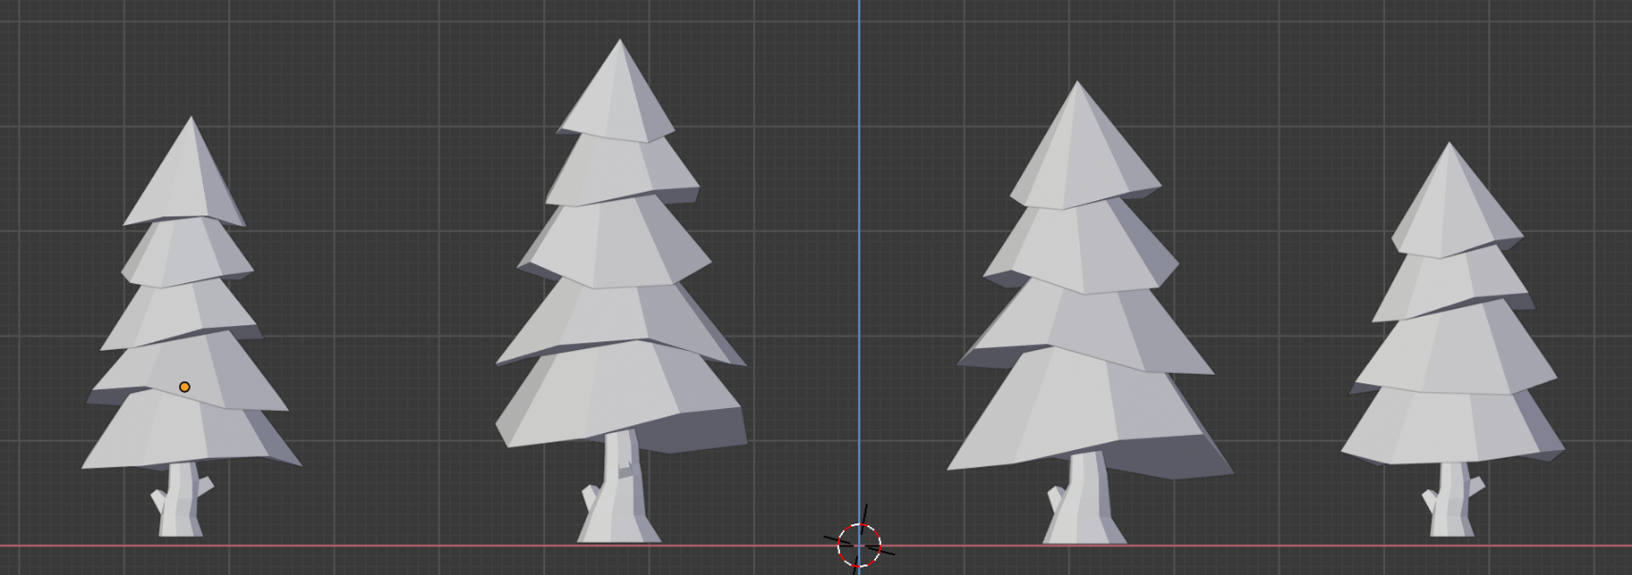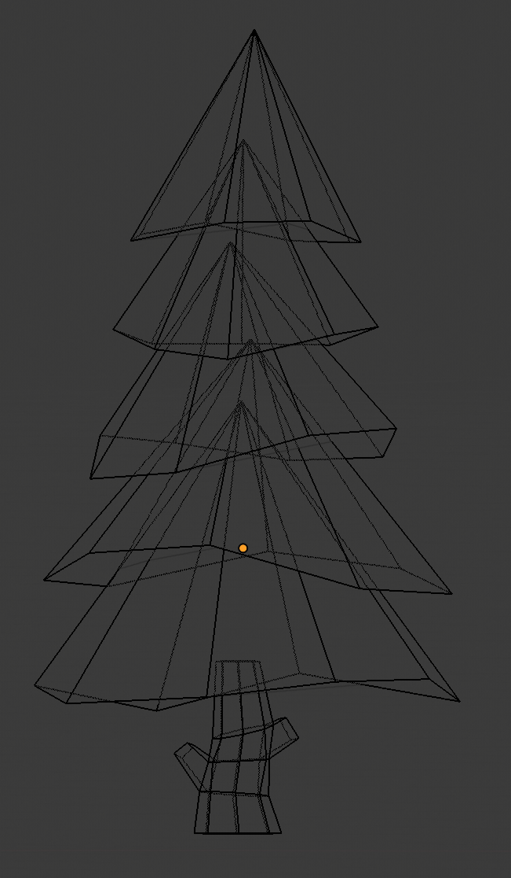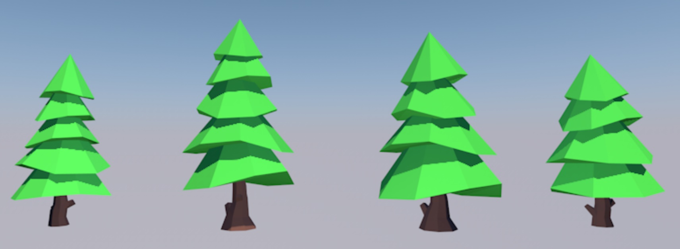I have created four different models of trees. The trees have to major parts, the leaves and the trunk. In order to make the shapes of the leaves I moved in different directions the points of pyramids. For the trunk I have used a cylinder. I used the extrude surfaces technique in order to make the specific shape.

Figure 17 – Tree Models

Figure 18 - Tree Models

## 5.7 Stones:

I have created four different models of stones. To make a stone I use a UV sphere. I subdivide the surfaces and switch to Sculpt Mode. I select the Scrape sculpting tool and I click in the sphere until I will have a nice shape. I use the decimate modifier in order to make the surfaces sharper and now I have a low poly stone.

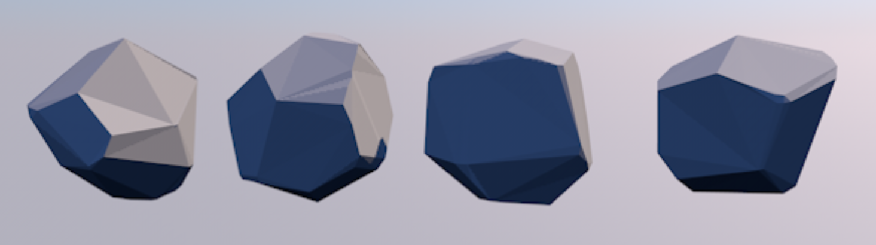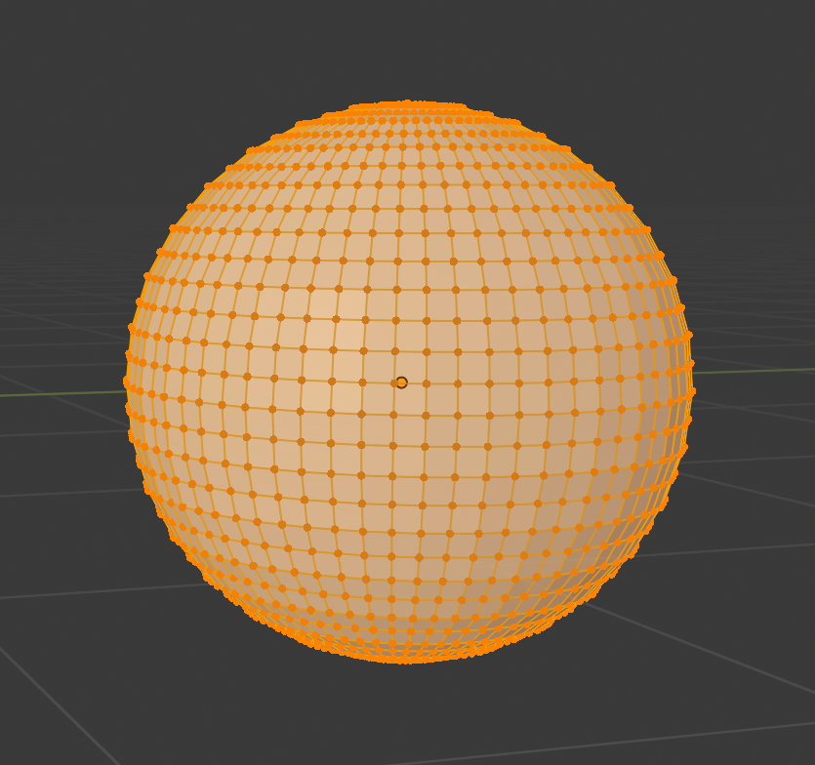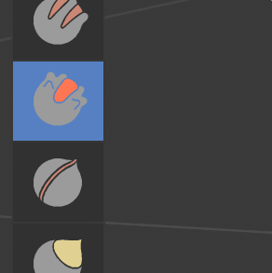

**2. Sculpt Mode**

**1. UV Sphere**

**4. Final Shape**

**3. Sculpt Sphere**

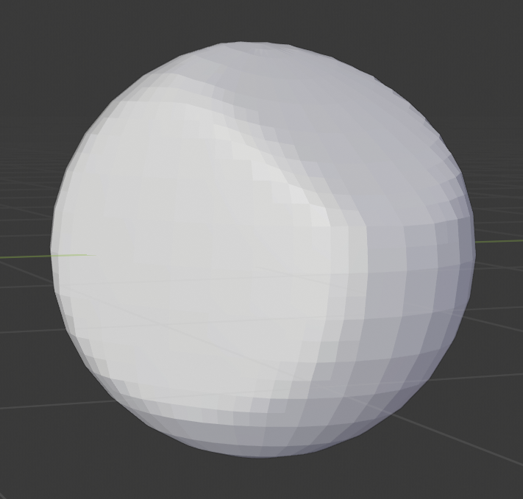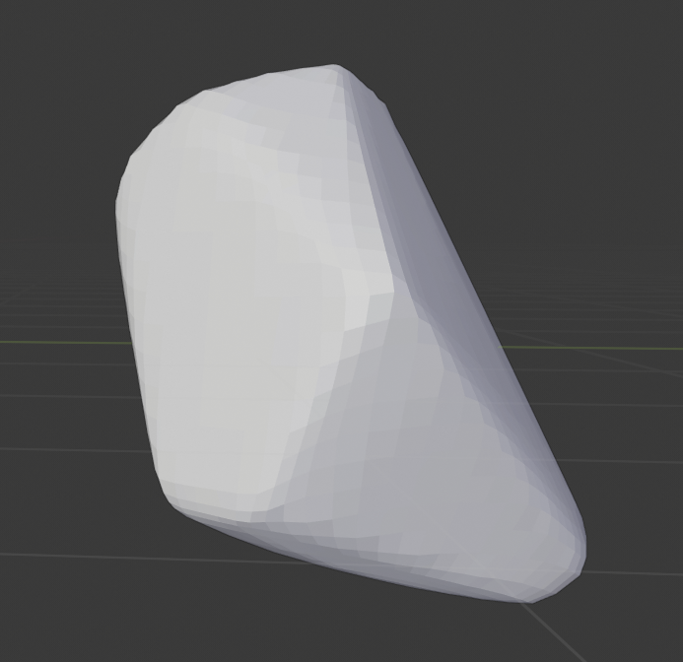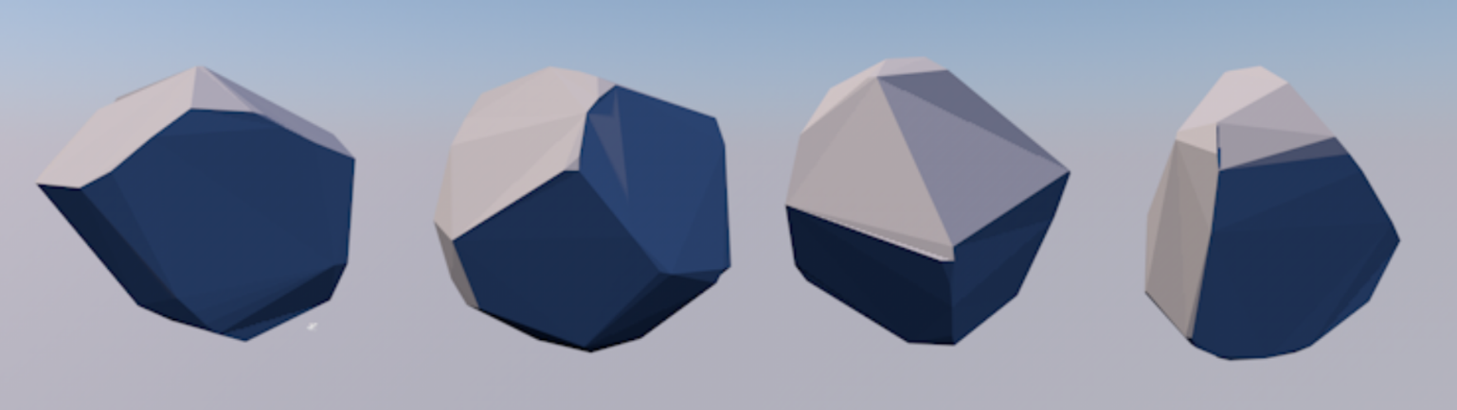

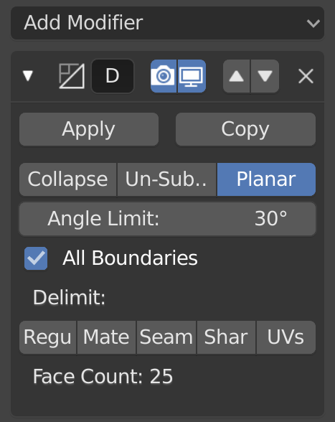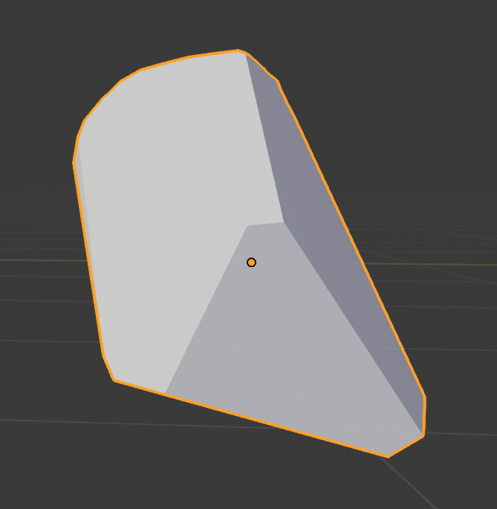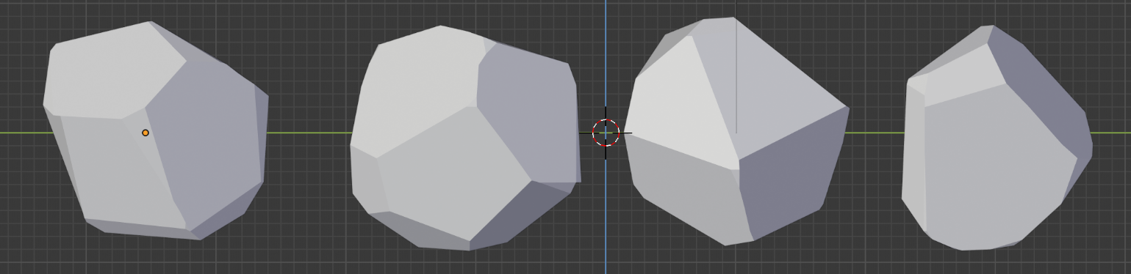

**6. End Result**

**5. Decimate Modifier**

Figure 18 - Stone Models

## 5.8 Scene:

All the 3D models were created in Blender 2.8, but for the presentation I found it better and easier to assemble them in Maxon Cinema 4D. I used as background the Physical Sky available in Cinema 4D and some lights in order to create a better atmosphere for my characters.

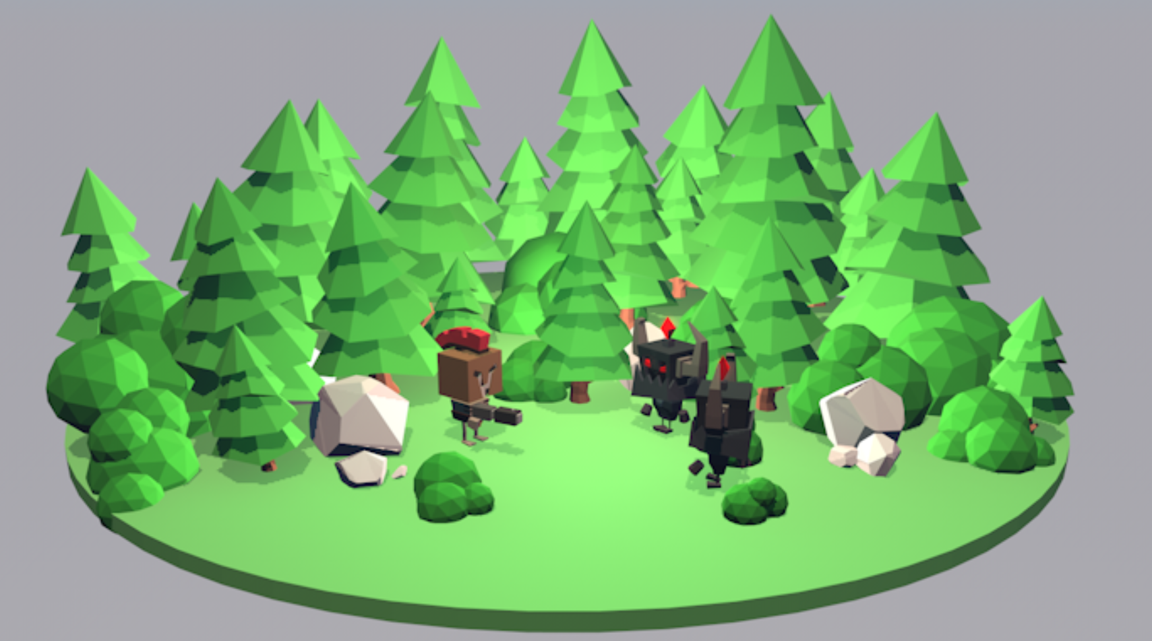

Figure 19 - Scene Front View

**Chapter 6** - Results:

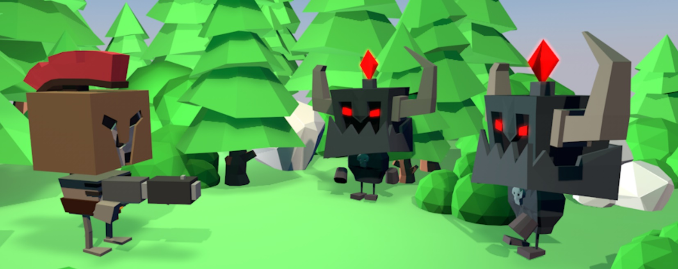In the following pictures we can see clearly the glowing red material in the gem and the eyes of the Enemy. We can see the gold metallic material in the belt of the Hero. We can see that the characters look good from different angles. Especially the Enemies that they consist of complex shapes look very interesting and aggressive.

Figure 20 - Scene Close Up

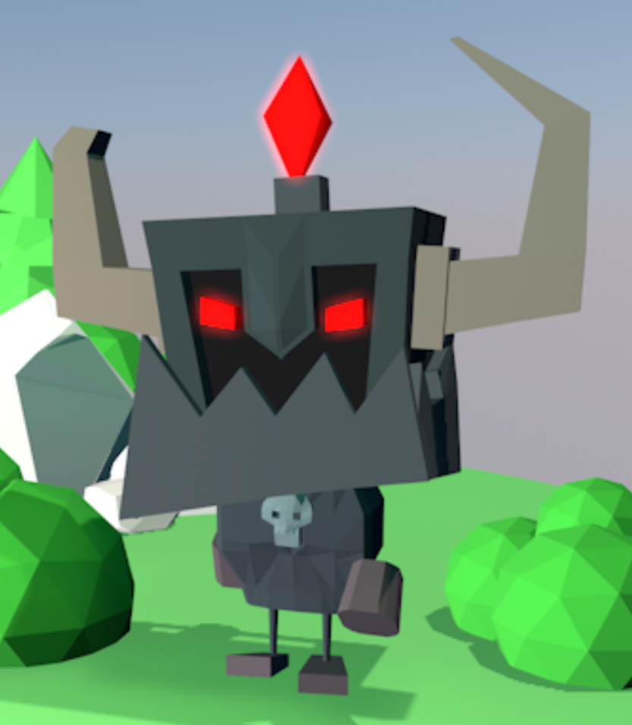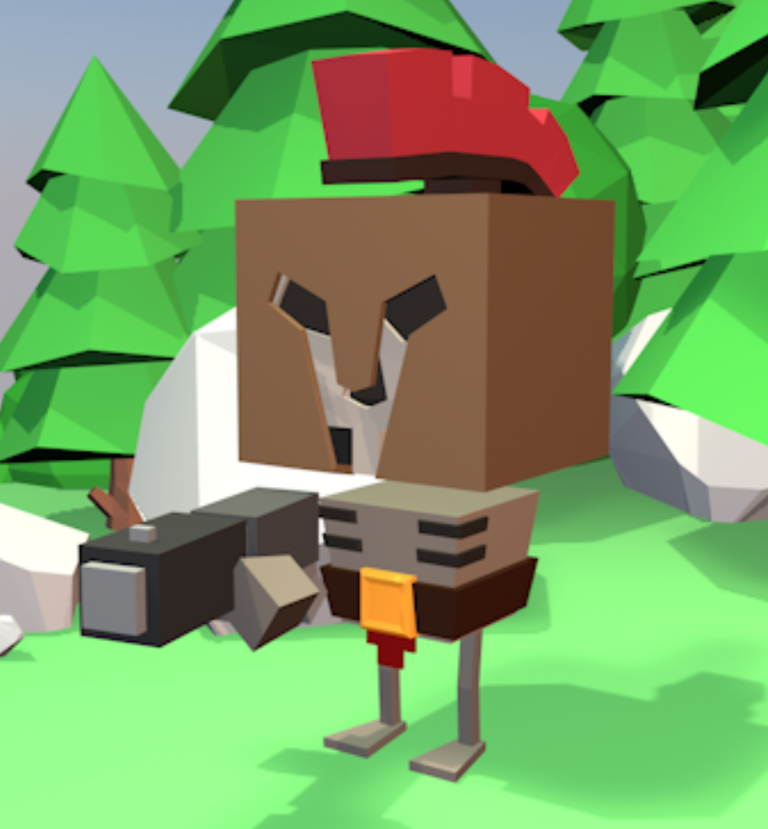

Figure 21 - Enemy Close Up

Figure 22 - Hero Close Up

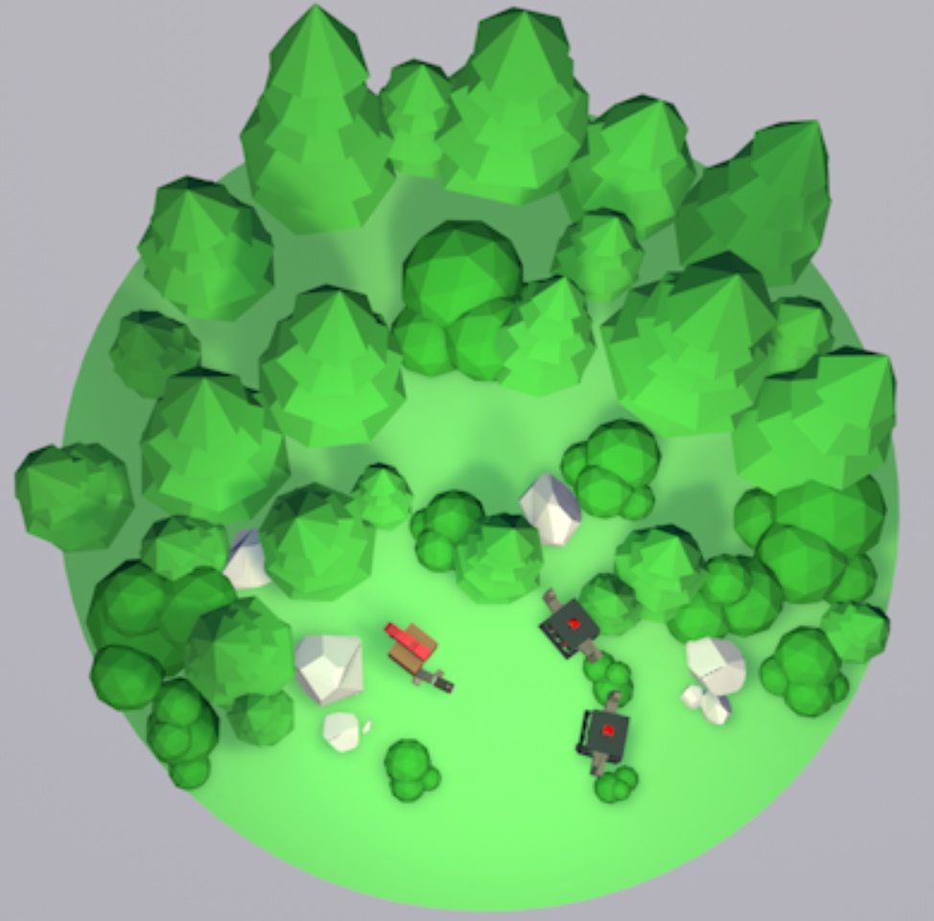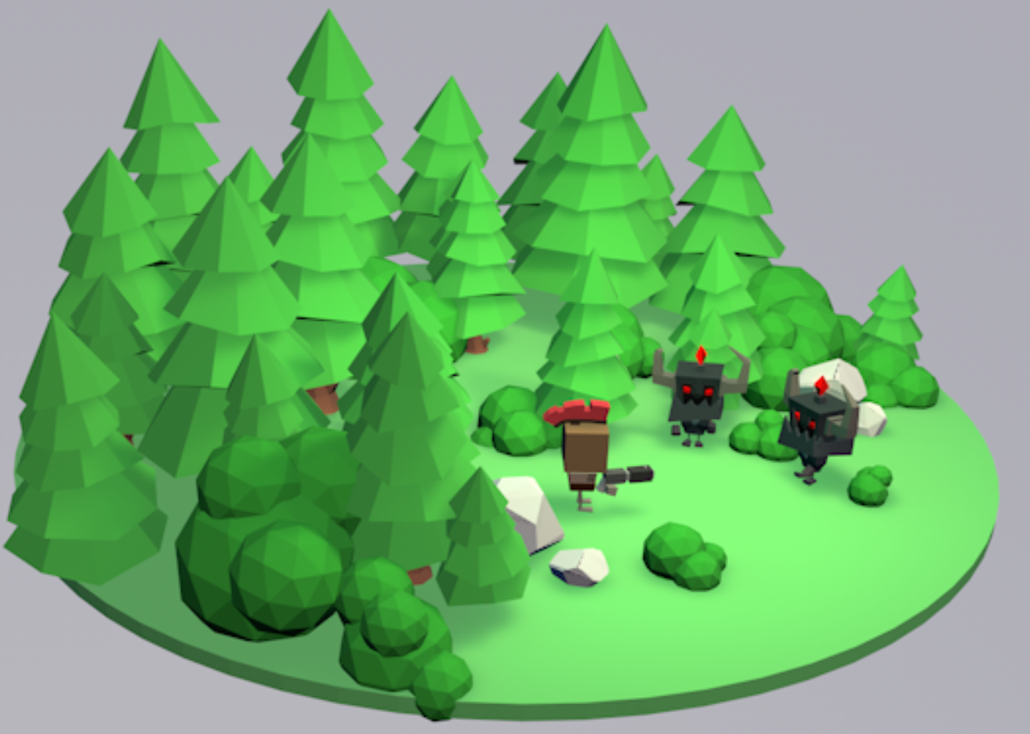 I have used a cylinder with big diameter and small height in order to create the ground for the scene. In the scene I have added multiple trees. Even if I had only four different tree models, I could increase their size and change their rotation in order to make a more natural environment. I did the same for the bushes and the stones. I am using some directional lights in order to make the Hero and the Enemies look more focused.

Figure 23 - Side Scene View

Figure 24 - Top-down Scene View

# **Chapter 7** - Conclusion:

I am very satisfied from the final overall result of the project. If I had more time, I would like to animate the characters too in order to see them moving. I would like to implement walk animations for the Hero and the Enemies. Also, maybe an attack animation for the Enemies. In general, I liked the procedure of creating 3D models for games and the fact that I could transform something from my 2D drafts to an actual 3D. As my first touch with a 3D modeling software I found it quite difficult to use Blender. I am sure that after practice I would be able to make much better graphics for my game. I understood after creating all those models that Blender is not a good software for creating models with precise dimensions. I think that is a very complicated software especially for begginers. The course in general will help me a lot for my future as I would like to become a Game Developer.

# **Chapter 8** - References:

* Low poly trees YouTube tutorial: <https://www.youtube.com/watch?v=yY-a4bypeIw>
* Character Technique YouTube tutorial: <https://www.youtube.com/watch?v=0QT1GNMevfc&t=1s>
* Rigging YouTube tutorial: <https://www.youtube.com/watch?v=cp1YRaTZBfw&t=8s>
* Spring – Blender Open Movie in YouTube (I saw it and then I cried because my graphics are not as good): <https://www.youtube.com/watch?v=WhWc3b3KhnY>